3. Memory Management
The term Memory can be defined as a collection of data in a specific format. It is used to store instructions and processed data. The memory comprises a large array or group of words or bytes, each with its own location.
The primary motive of a computer system is to execute programs. These programs, along with the information they access, should be in the main memory during execution. The CPU fetches instructions from memory according to the value of the program counter.
To achieve a degree of multiprogramming and proper utilization of memory, memory management is important.
In a multiprogramming computer, the operating system resides in a part of memory and the rest is used by multiple processes. The task of subdividing the memory among different processes is called memory management. Memory management is a method in the operating system to manage operations between main memory and disk during process execution. The main aim of memory management is to achieve efficient utilization of memory.

3.1 Memory Hierarchy

In the Computer System Design, Memory Hierarchy is an enhancement to organize the memory such that it can minimize the access time. The Memory Hierarchy was developed based on a program behavior known as locality of references. The figure below clearly demonstrates the different levels of memory hierarchy:
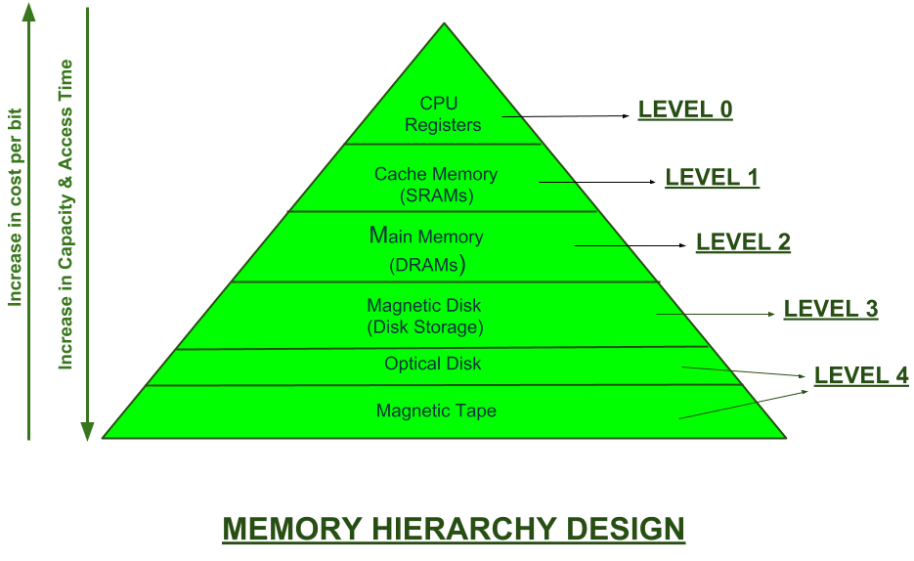

This Memory Hierarchy Design is divided into 2 main types:

External Memory or Secondary Memory:
Comprising of Magnetic Disk, Optical Disk, Magnetic Tape i.e. peripheral storage devices which are accessible by the processor via I/O Module.
Internal Memory or Primary Memory:
Comprising of Main Memory, Cache Memory & CPU registers. This is directly accessible by the processor.
We can infer the following characteristics of Memory Hierarchy Design from above figure:

Capacity:
It is the global volume of information the memory can store. As we move from top to bottom in the Hierarchy, the capacity increases.
Access Time:
It is the time interval between the read/write request and the availability of the data. As we move from top to bottom in the Hierarchy, the access time increases.
Performance:
Earlier when the computer system was designed without Memory Hierarchy design, the speed gap increases between the CPU registers and Main Memory due to large difference in access time. This results in lower performance of the system and thus, enhancement was required. This enhancement was made in the form of Memory Hierarchy Design because of which the performance of the system increases. One of the most significant ways to increase system performance is minimizing how far down the memory hierarchy one has to go to manipulate data.
Cost per bit:
As we move from bottom to top in the Hierarchy, the cost per bit increases i.e. Internal Memory is costlier than External Memory.

3.2 Functionality
- Keep track of what memory is in use and what memory is free.
- Allocate and deallocation of memory accordingly.
- Proper utilization of memory.
- Keep updating status of process
- Memory manages that move processes back and forth between memory and disk during execution

3.3 Mono programming model
In mono-programming, memory contains only one program at any point of time. Whereas in multiprogramming memory contains more than one user program. In case of mono programming, when CPU is executing the program and I/O operation is encountered, then the program goes to I/O devices, during that time CPU sits idle. Thus, in mono-programming CPU is not effectively used i.e., CPU utilization is poor.
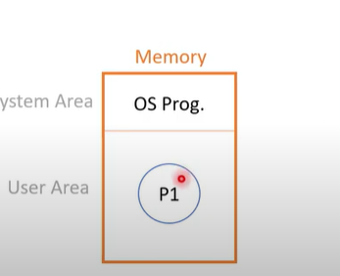

Disadvantages
- Insufficient utilization of memory
- CPU remains idle, if process go for IO and IO device remains idle, if process takes CPU

3.4 Multi programming model
The degree of multiprogramming describes the maximum number of processes that a single-processor system can accommodate efficiently.
The primary factor is the amount of memory available to be allocated to executing process. If the amount of memory is too limited, the degree of multiprogramming will be limited because fewer processes will fit in memory.
Logical and Physical Address Space:
Logical Address space: An address generated by the CPU is known as “Logical Address”. It is also known as a Virtual address. Logical address space can be defined as the size of the process. A logical address can be changed.

Physical Address space: An address seen by the memory unit (i.e the one loaded into the memory address register of the memory) is commonly known as a “Physical Address”. A Physical address is also known as a Real address. The set of all physical addresses corresponding to these logical addresses is known as Physical address space. A physical address is computed by MMU. The run-time mapping from virtual to physical addresses is done by a hardware device Memory Management Unit(MMU). The physical address always remains constant.
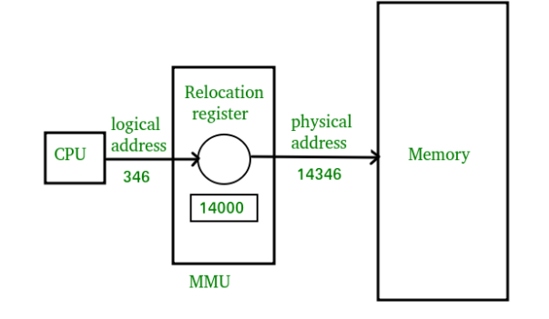
Memory management unit is a hardware device that maps virtual addresses to physical addresses.
Relocation register/ Base register is simply a start address of a program in physical memory.

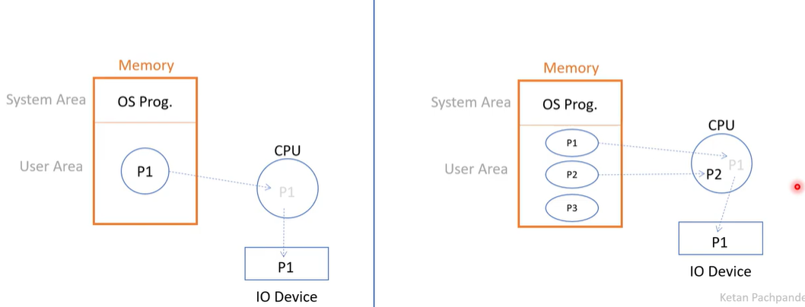

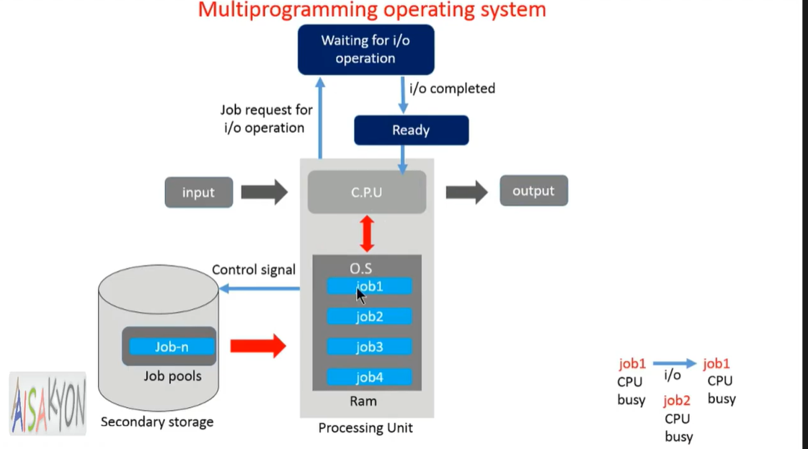

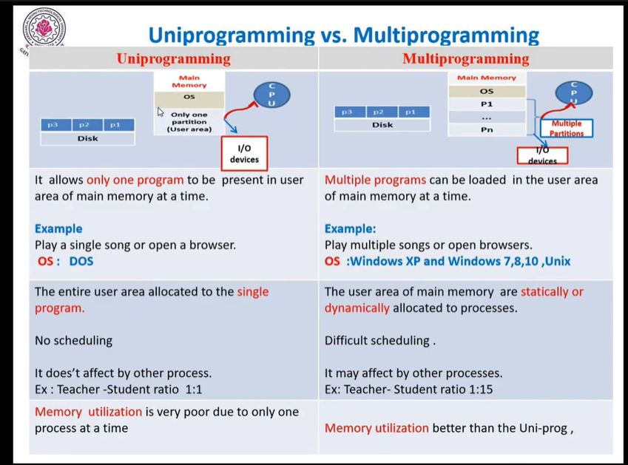
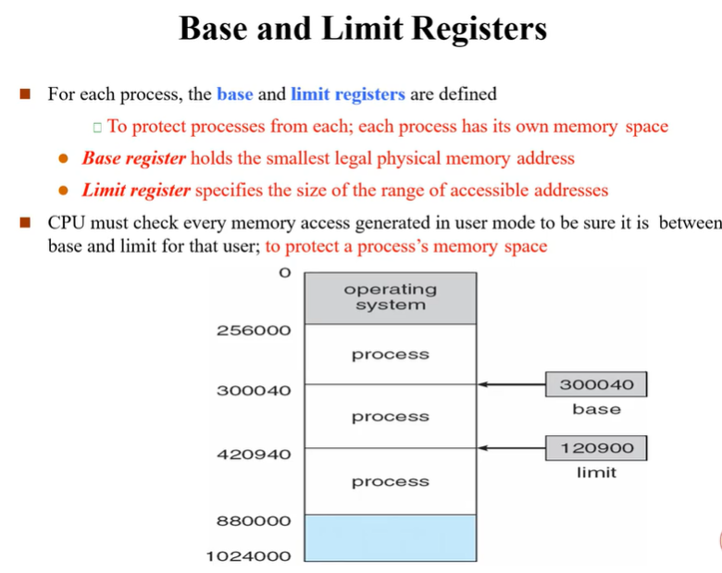

3.5 Requirements of Memory Management

3.5.1 Sharing
A protection mechanism must have to allow several processes to access the same portion of main memory. Allowing each processes access to the same copy of the program rather than have their own separate copy has an advantage.
For example, multiple processes may use the same system file and it is natural to load one copy of the file in main memory and let it shared by those processes. It is the task of Memory management to allow controlled access to the shared areas of memory without compromising the protection. Mechanisms are used to support relocation supported sharing capabilities.

3.5.2 Protection
There is always a danger when we have multiple programs at the same time as one program may write to the address space of another program. So, every process must be protected against unwanted interference when other process tries to write in a process whether accidental or incidental.
The word protection means provide security from unauthorized usage of memory. The operating can protect the memory with the help of base and limit register. Base registers consisting of the starting address of the next process. The limit specifies the boundary of that job, so the limit register is also said to be a fencing register.

3.6 Memory Management Techniques

3.6.1 Contiguous Memory Allocation
Contiguous memory allocation is basically a method in which a single contiguous section/part of memory is allocated to a process or file needing it. Because of this all the available memory space resides at the same place together, which means that the freely/unused available memory partitions are not distributed in a random fashion here and there across the whole memory space.
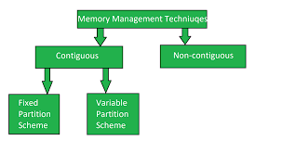

3.6.1.1 Fixed Partition
The earliest and one of the simplest techniques which can be used to load more than one processes into the main memory is Fixed partitioning or Contiguous memory allocation.
In this technique, the main memory is divided into partitions of equal or different sizes. The operating system always resides in the first partition while the other partitions can be used to store user processes. The memory is assigned to the processes in contiguous way.
In fixed partitioning,
- The partitions cannot overlap.
- A process must be contiguously present in a partition for the execution.
Cons:
- Internal Fragmentation
- External Fragmentation
- Limit on the size of the process
- Limitation on degree of multi programming
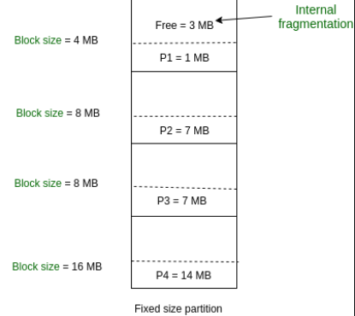

3.6.1.1 Dynamic/Variable Partition
It is a part of Contiguous allocation technique. It is used to alleviate the problem faced by Fixed Partitioning. In contrast with fixed partitioning, partitions are not made before the execution or during system configure.
Various features associated with variable Partitioning-
Initially RAM is empty, and partitions are made during the run-time according to process’s need instead of partitioning during system configure.
The size of partition will be equal to incoming process.
The partition size varies according to the need of the process so that the internal fragmentation can be avoided to ensure efficient utilization of RAM.
Number of partitions in RAM is not fixed and depends on the number of incoming process and Main Memory’s size.
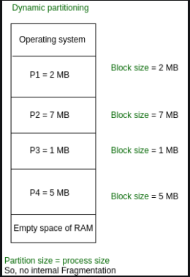

Advantages of Variable Partitioning –
- No Internal Fragmentation
- No restriction on Degree of Multiprogramming
- No Limitation on the size of the process:

Disadvantages of Variable Partitioning –
- Difficult Implementation
- External Fragmentation

3.7 Internal and External Fragmentation
Internal Fragmentation:
Internal fragmentation happens when the memory is split into mounted-sized blocks. Whenever a method is requested for the memory, the mounted-sized block is allotted to the method. just in case the memory allotted to the method is somewhat larger than the memory requested, then the distinction between allotted and requested memory is that the internal fragmentation.

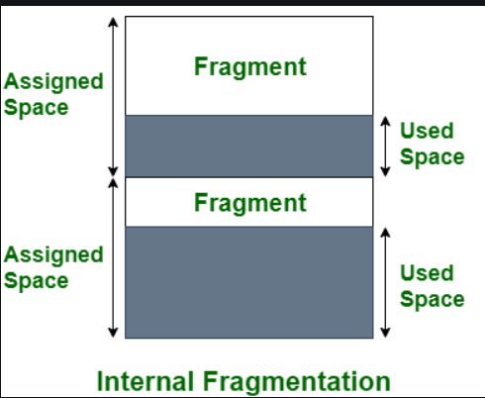
The above diagram clearly shows the internal fragmentation because the difference between memory allocated and required space or memory is called Internal fragmentation.
2. External Fragmentation:
External fragmentation happens when there’s a sufficient quantity of area within the memory to satisfy the memory request of a method. However, the process’s memory request cannot be fulfilled because the memory offered is in a non-contiguous manner.
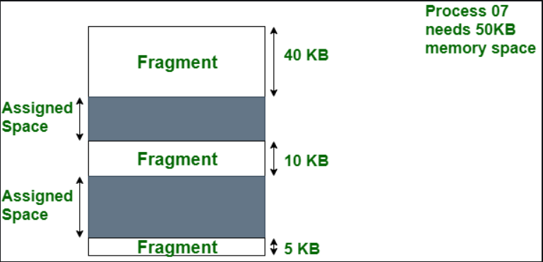
In the above diagram, we can see that, there is enough space (55 KB) to run a process-07 (required 50 KB) but the memory (fragment) is not contiguous. Here, we use compaction, paging, or segmentation to use the free space to run a process.

3. Concept of Virtual memory and Paging
Virtual memory
A computer can address more memory than the amount physically installed on the system. This extra memory is actually called virtual memory and it is a section of a hard disk that's set up to emulate the computer's RAM.
The main visible advantage of this scheme is that programs can be larger than physical memory. Virtual memory serves two purposes. First, it allows us to extend the use of physical memory by using disk. Second, it allows us to have memory protection, because each virtual address is translated to a physical address.
It is a technique that is implemented using both hardware and software. It maps memory addresses used by a program, called virtual addresses, into physical addresses in computer memory.
- All memory references within a process are logical addresses that are dynamically translated into physical addresses at run time. This means that a process can be swapped in and out of the main memory such that it occupies different places in the main memory at different times during the course of execution.
- A process may be broken into a number of pieces and these pieces need not be continuously located in the main memory during execution. The combination of dynamic run-time address translation and use of page or segment table permits this.

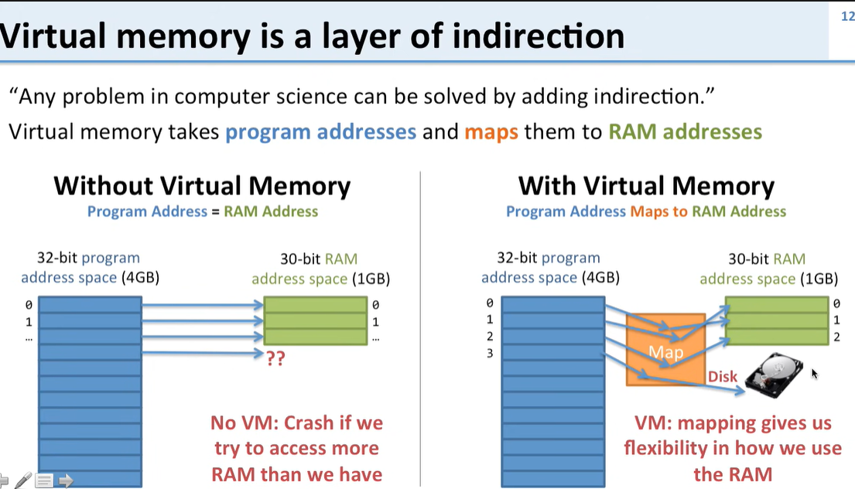

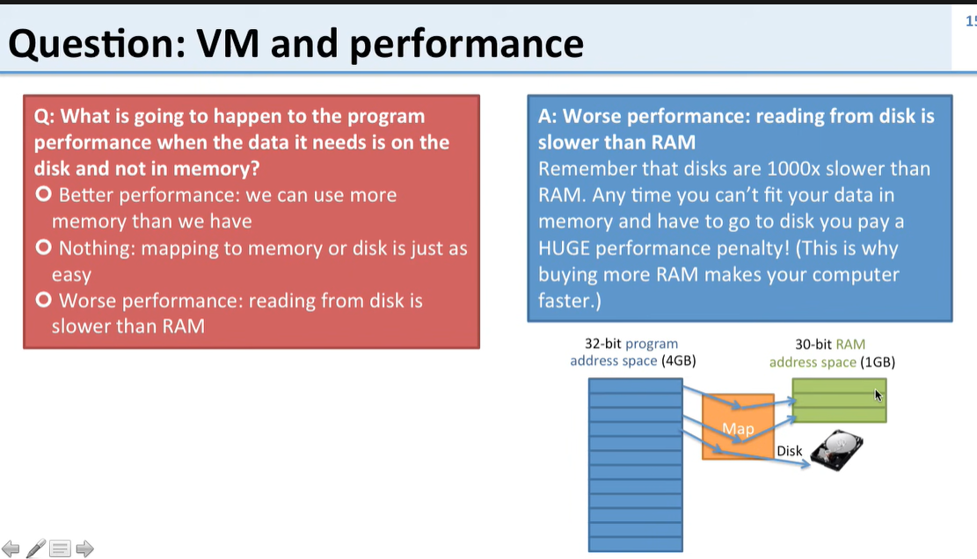

Paging
In Operating Systems, Paging is a storage mechanism used to retrieve processes from the secondary storage into the main memory in the form of pages.
The main idea behind the paging is to divide each process in the form of pages. The main memory will also be divided in the form of frames. One page of the process is to be stored in one of the frames of the memory. The pages can be stored at the different locations of the memory but the priority is always to find the contiguous frames or holes.
Pages of the process are brought into the main memory only when they are required otherwise they reside in the secondary storage.
Different operating system defines different frame sizes. The sizes of each frame must be equal. Considering the fact that the pages are mapped to the frames in Paging, page size needs to be as same as frame size.

Example
Let us consider the main memory size 16 Kb and Frame size is 1 KB therefore the main memory will be divided into the collection of 16 frames of 1 KB each.
There are 4 processes in the system that is P1, P2, P3 and P4 of 4 KB each. Each process is divided into pages of 1 KB each so that one page can be stored in one frame.
Initially, all the frames are empty therefore pages of the processes will get stored in the contiguous way.
Frames, pages and the mapping between the two is shown in the image below.
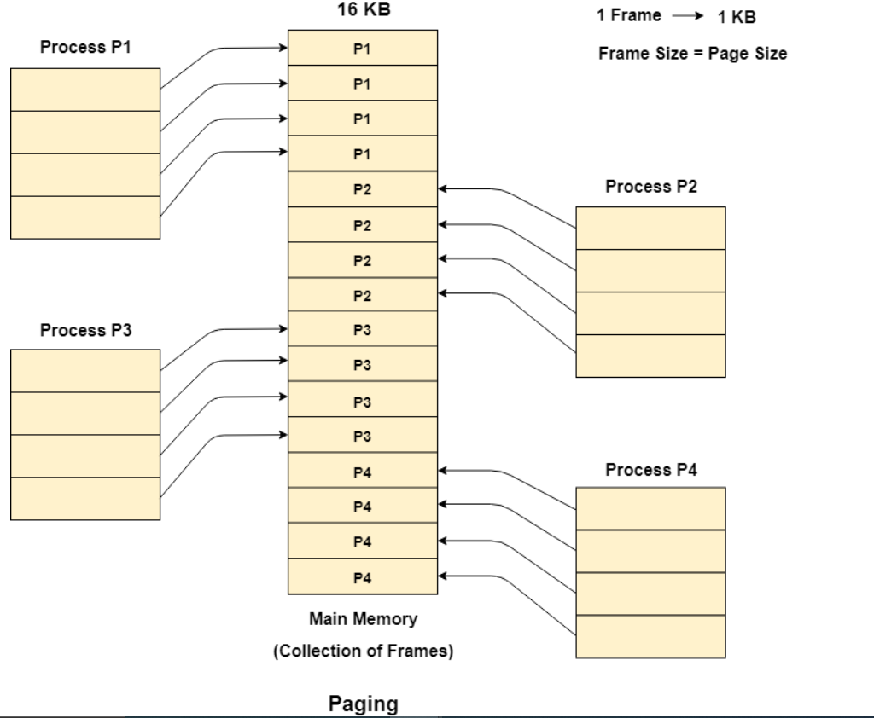

Let us consider that, P2 and P4 are moved to waiting state after some time. Now, 8 frames become empty and therefore other pages can be loaded in that empty place. The process P5 of size 8 KB (8 pages) is waiting inside the ready queue.
Given the fact that, we have 8 non contiguous frames available in the memory and paging provides the flexibility of storing the process at the different places. Therefore, we can load the pages of process P5 in the place of P2 and P4.
